# Information Visualization

# CHECKPOINT I: Visualization Proposal

G08

**1. Domain**

- Our domain for the project is the **employment/unemployment** of higher education courses from all the public and private universities of Portugal during the period of 2007-2015.

**2. Dataset**

* + - 1. - We will use a set of documents (excel format) provided by DGEEC (“Direção-Geral de Estatísticas da Educação e Ciência”) with the information about all the courses and the respective year.
    1. - The data mentioned above is in the DGEEC website, available at http://www.dgeec.mec.pt/np4/92/
       1. **3. Tasks to be supported**

- Task 1: Query->Compare - Compare the unemployment (%) of different courses (regardless of course conclusion year of the graduates)

- Task 2: Analyze->Consume->Present – Present the information about unemployment (%) from a specific course graduates across time

- Task 3: Query->Identify – Identify the university with more unemployment (%)

- Task 4: Consume->Present – Relation between minimum entry grade and unemployment (%)

-Task 5: Query->Summarize – Summarize the employment/unemployment by graduation areas

**4. Example Questions**

- Does Computer Science graduates in IST have more unemployment, in 2015, than Computer Science in ISEL? And in 2007? (Task 1)

- Is Computer Science in IST having less unemployed graduates in last years? (Task 2)

- What was the year which had less unemployed people from Computer Science in IST? (Task 2)

- What is the university with more unemployment? (Task 3)

- Where the unemployment will be higher? In a course with 14 minimum entry grade or one with 17? (Task 4)

- What is the graduation area with less/more unemployment? (Task 5)

**5. Data Sample**

Unemployment data is available from 2007 to 2015

(from “Unemployment2013.xls”)

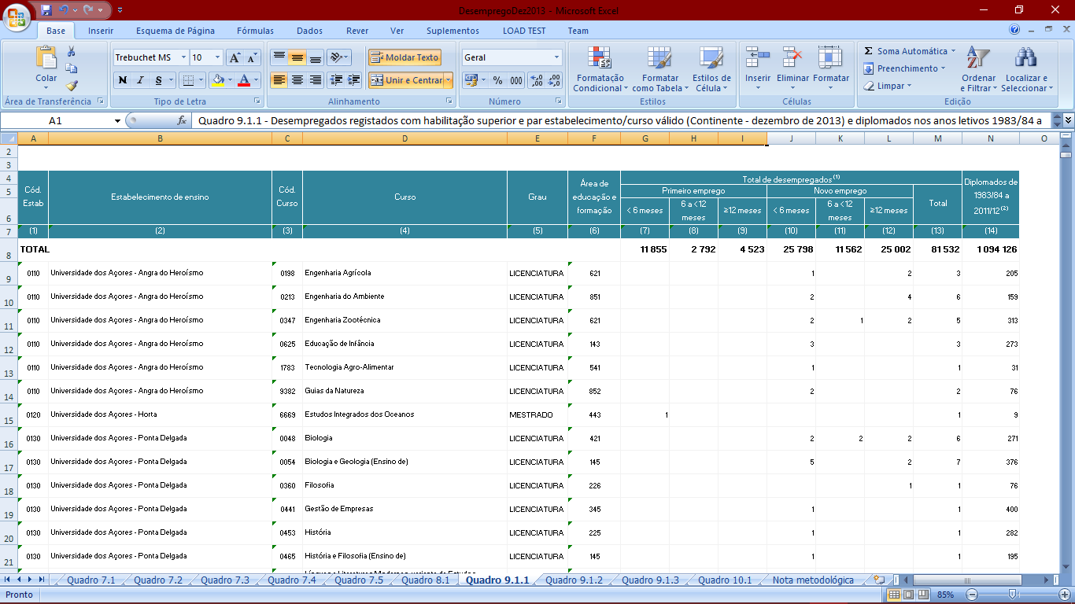

(from “Unemployment2012.xls”)

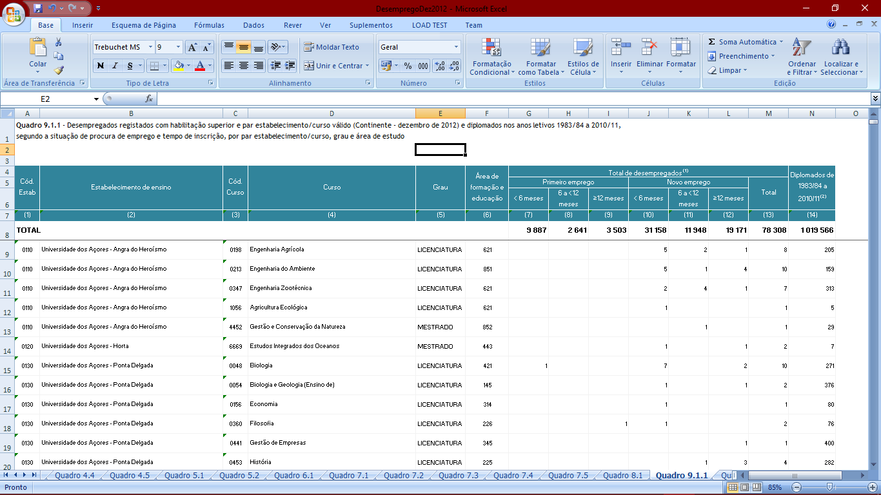

(from “EntryGrades2016.xls”)

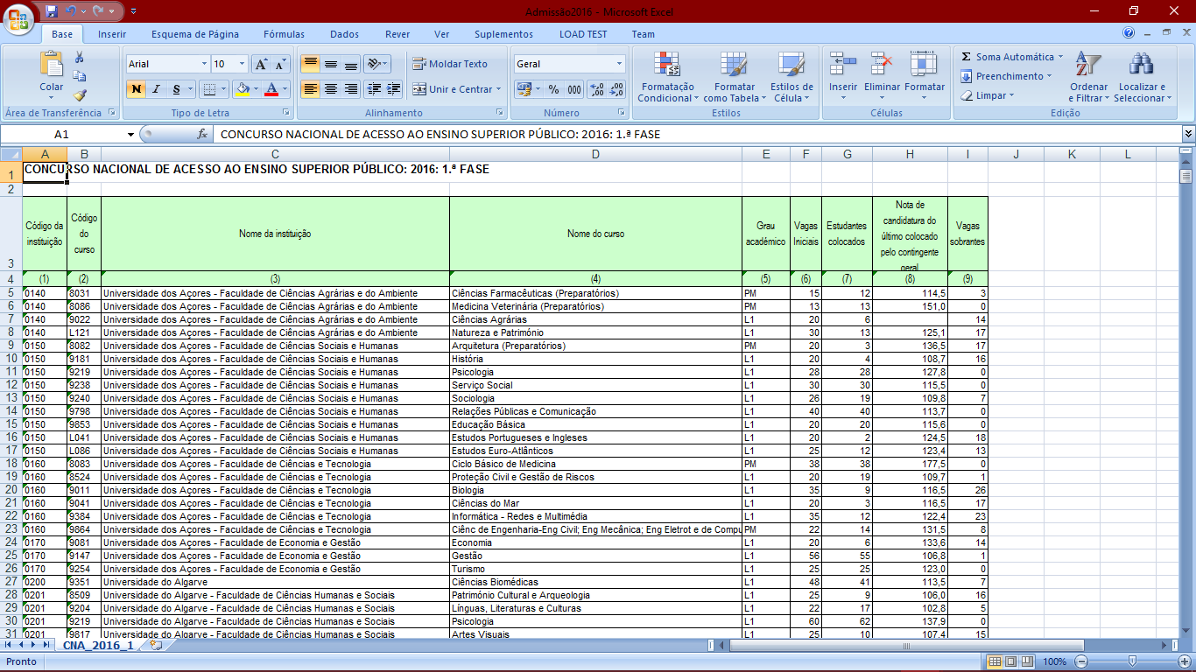

(from “CourseAreas.xls”)

